LAJ REVIEWER FORM

Date sent by editor: | 6 March 2020
Name of reviewer: | Professor Andy Alfatih
Manuscript title: | Reducting Corruption through e-Government Adoption, Information and Communication technology in ASEAN Countries

GENERAL GUIDELINES: We appreciate very much your willingness to review this manuscript. The Local Administration Journal (JAL) endeavors to publish papers of high scholarly quality. To achieve this, we value highly your assessment and recommendations regarding the attached manuscript’s publishability in the Journal. Please provide a constructive critique of the manuscript. Your identity as a reviewer is confidential but the editor may draw direct quotes to guide the author in strengthening the manuscript.
CONFIDENTIALITY: By accepting to be a reviewer, you are required to maintain strict confidentiality regarding the content, identity and existence of this manuscript until it is officially accepted for publishing.

GENERAL EVALUATION (put a mark where appropriate):
Excellent overall
Very important contribution, well presented
Competent study, well presented
Technically accurate, but obvious findings
Flawed in design or execution
Insufficient data for a scholarly paper
Poorly written and/or argued

RECOMMENDATION (put a mark on ONE only):
Accept as is, without modification
Accept on condition of minor revisions
Accept on condition of extensive revisions
Reject, should not be published in its present form

MAIN CONTENT (for each of the items below, put a mark where appropriate):
 | Yes | No
Is the manuscript and its rationale clearly written?
Are the methodological aspects of the manuscript correct?
Are the interpretations and conclusions appropriate and well substantiated?

STRUCTURE AND FORMAT (put a mark where appropriate):
 | Yes | No
Is the title appropriate?
Is the abstract appropriate?
Is the manuscript logically organized with its tables & figures well presented?
Should additional work be done to strengthen the manuscript?

GENERAL COMMENTS:

To make readers understand and be comfortable reading this article, the above comments must be well corrected. Then, it can be considered to publish.

SPECIFIC COMMENTS:
In a narrative format, please indicate where reworking has to be done. Provide specific comments to guide the author. (You may wish to put your specific comments at the relevant parts of the manuscript itself directly for easy reference.)

1. Some mistakes in tenses should be corrected. Some of them have been high-lighted.
2. Research questions raised in this study are not clear.
3. The author is too busy and too much presented theories, in terms of definitions, descriptions, statements, and other information for unclear reasons what they are for.
4. Data on every ASEAN countries which was studied specifically were not well classified and not clear.
5. The description on how data analysis and the tools reduce corruption through e-government and ICT is not obvious, either.
6. The conclusion is not clear [ does not state clearly how e-government and ICT overcome corruption. It only repeats the presented statements again and again. It is, even, indicated expressing other people’s ideas.

Reviewer’s signature: Date sent by reviewer:
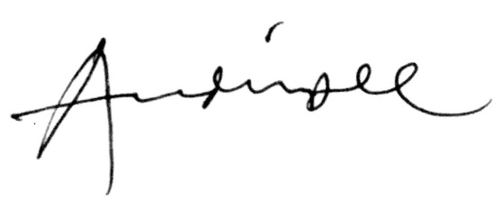
6 March 2020

Andy Alfatih

