https://elearning222.unsri.ac.id/mod/attendance/manage.php?id=88762
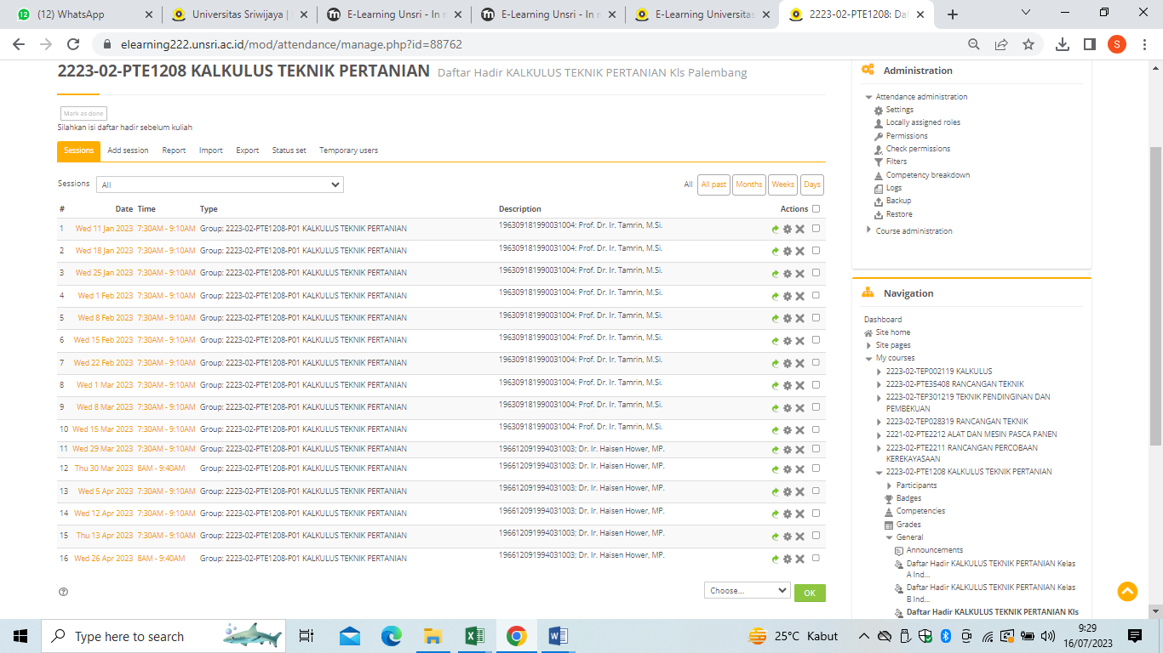

https://elearning222.unsri.ac.id/mod/attendance/manage.php?id=86200&view=5
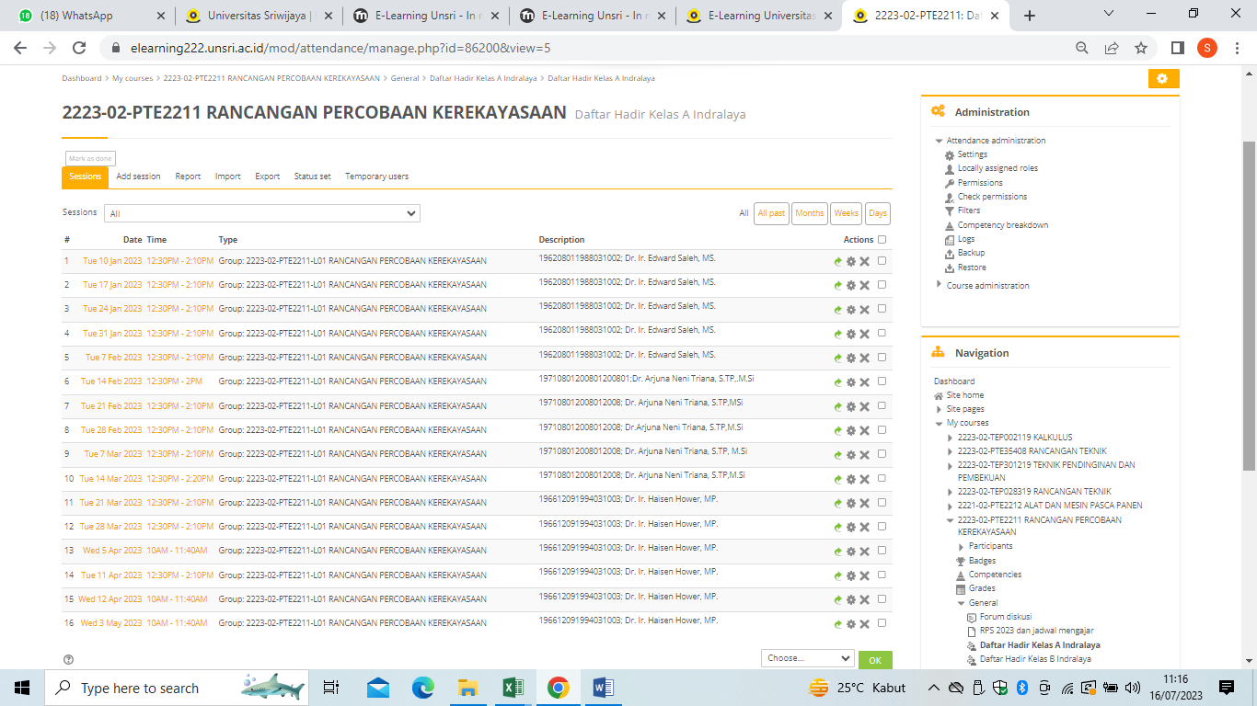

https://elearning222.unsri.ac.id/mod/attendance/manage.php?id=88758&view=5
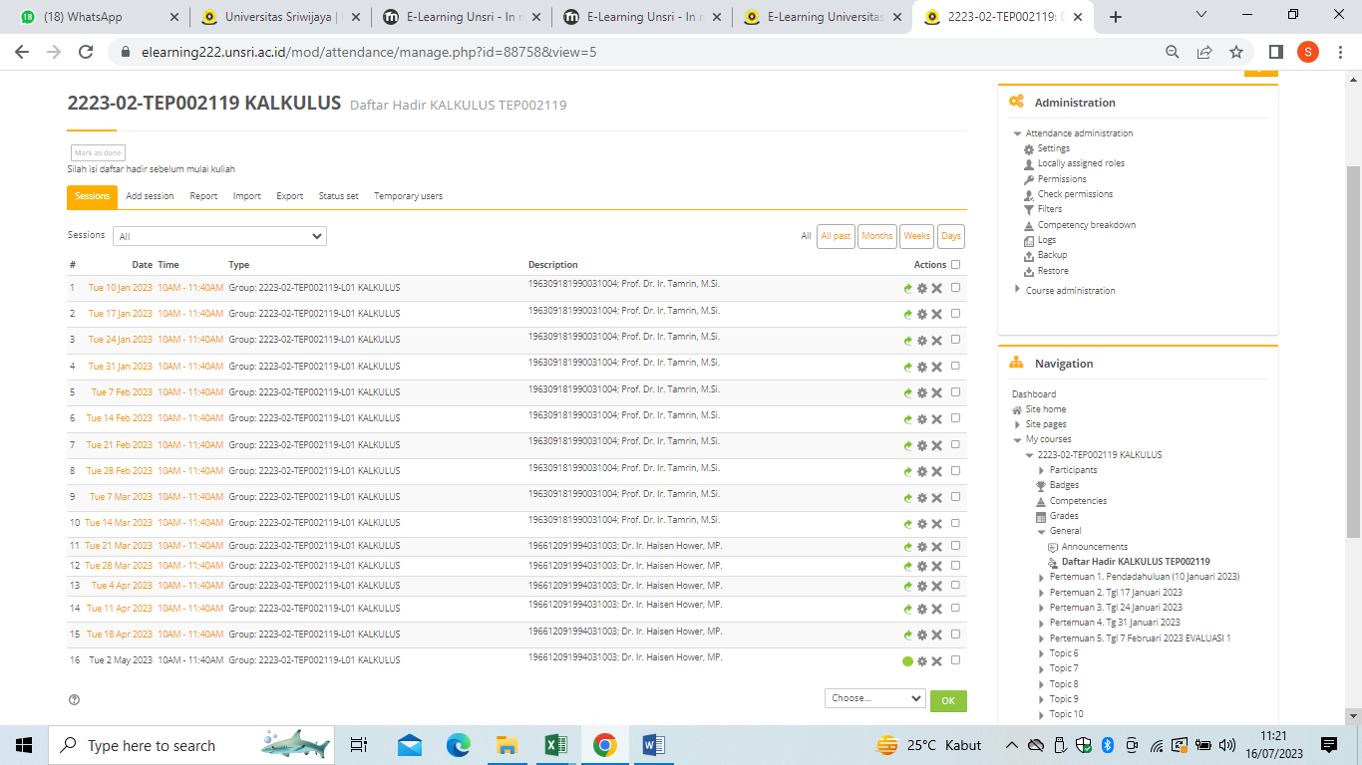

https://elearning222.unsri.ac.id/mod/attendance/manage.php?id=114046&view=5
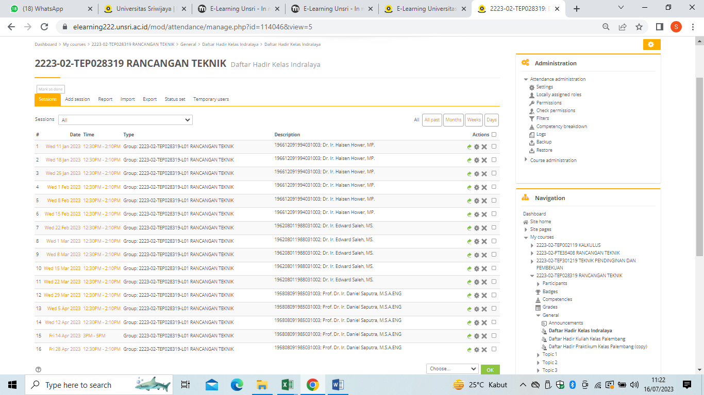

https://elearning222.unsri.ac.id/mod/attendance/manage.php?id=114496
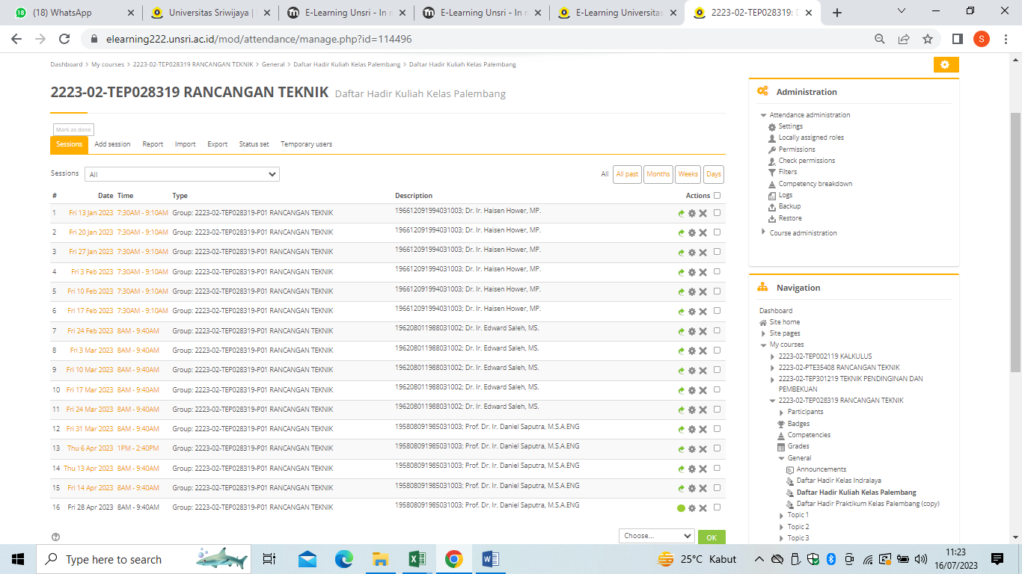

https://elearning222.unsri.ac.id/mod/attendance/manage.php?id=103363&view=5
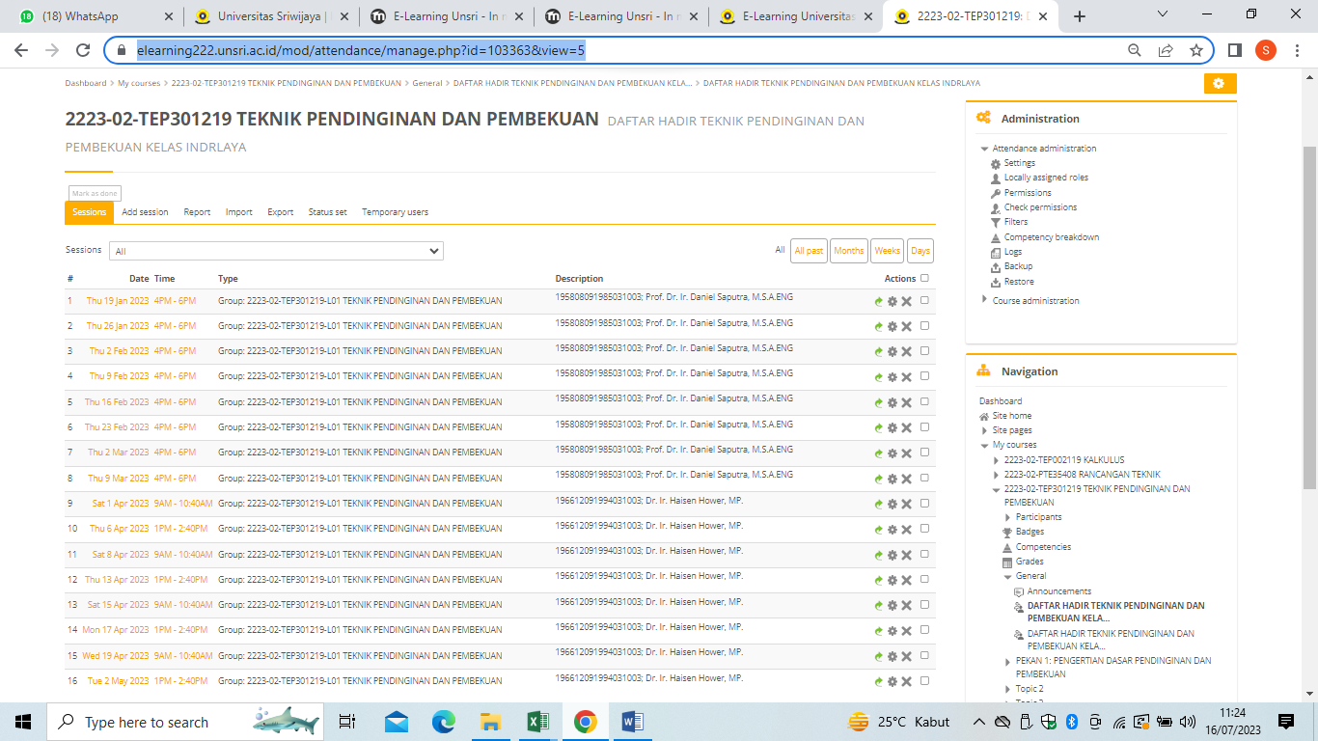

https://elearning222.unsri.ac.id/mod/attendance/manage.php?id=103364
