Department of Environmental Science, Thai Nguyen University of Agriculture and Forestry

Lichens as Bioindicators of Air Quality
Arinafril, Inara Aziz, Aung Kaung Zan, Natasya Soares, Madalena Godinho, Jedidiah Par, Venancia Tereza da Silva

May 12, 2023

Report: Lichens as Bioindicator of Air Quality
- Introduction
Lichens have been used as an indicator of air quality since the year 1866 (Nylander 1866; Kricke & Loppi 2002; Conti & Cecchetti 2001). The ability of lichens to absorb toxic materials such as sulfur dioxide (SO2), fluorine (F2), and nitrogen dioxide gas (NO2) into the talus system for a long period of time has made the lichens a valuable indicator of air quality (Blett et al. 2003). As an indicator of air quality, lichens do not have cuticles to control the exchange of water, nutrients, gas, and other particles with the external environment. Instead, the absorption of nutrients is from the atmosphere and not from the root system.
- Purpose
The aim purpose of using lichens in this report was to determine the pollution in the area around our university TUAF (Thai Nguyen University of Agriculture and Forestry) where the lichens are going. The lichens will be used to measure the air pollution around the place where we put the lichens for 7 days to see the difference between the lichens’ form before and after 7 days.
- Procedure
- Collect 2 different types of lichens from different places, in here we are using Xanthoria calciola as a specie A and Flavopunctelia soredica as a specie B;
- Prepare board to tie the lichens or any other material that could hold the lichens, but here we used Styrofoam to keep our lichens from the rain and the direct light from the sun;
- Find some pillar to the board of the lichens or some kind of stick so the board could stand straight, in here we were using the metal stick to keep hold of the lichens;
- After putting the lichens on the board, make sure that the stick and the lichens are tight enough and won’t fall.

- Materials
- Styrofoam;
- Metal stick;
- Glue Gun
- Rope
- Paper
- Marker
- Methodology
In this experiment we selected two different places to put our lichens around our campus, the two places that we chose the most, mainly using transportation, to see how the lichens play an important role in absorbing the carbon and pollution from human daily activity. For the first place we chose behind the dormitory of K5 crossroads for lichens number 1, and for lichens number 2 we placed in front of the dormitory of K3. These two places are mainly used for any type of transportation and other daily activities like walking etc. After putting our lichens in both places, we are starting to count the transportation that goes by the lichens, here we divided the size and type of vehicles which are motorbikes, cars, and trucks, these types of vehicles are excluded from those electric transportation. We monitored the lichens before and after placing them in those two main areas for 7 days. To further see the result of this experiment, we will also use the software SPSS.
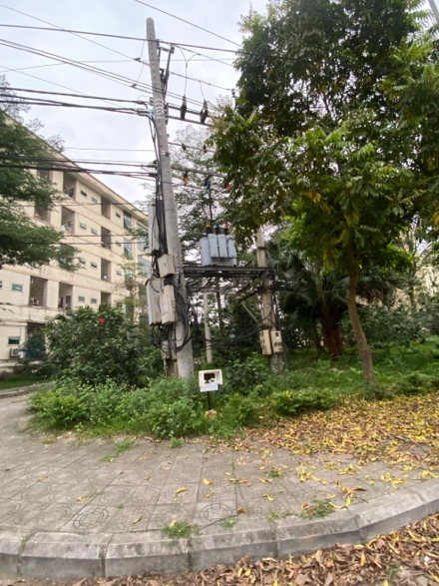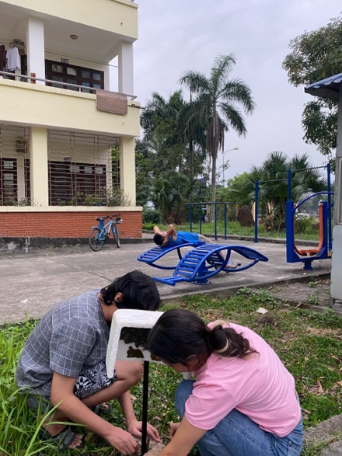
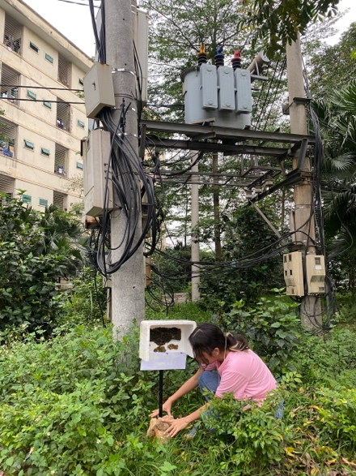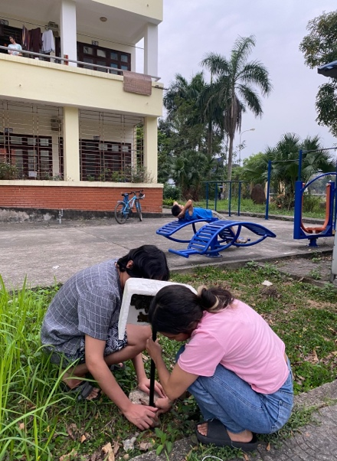
Placing the Lichens.
Location 1. Behind of dormitory K5
Location 2. In front of Domitory K3
- Results
- Day One (Date:07/04/2023)
- Lichens Number 1
- Picture 1:
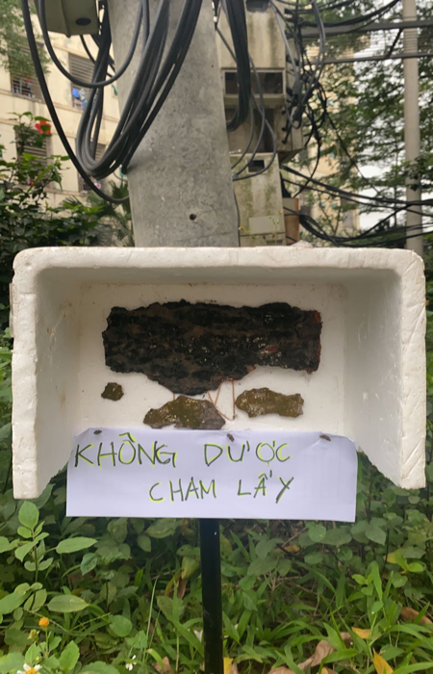
- Time: 18:00pm
- Motorbike: 28
- Car: 2
- Truck:0
- Lichens Number 2
- Picture 2:
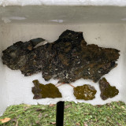
- Time: 18:00pm
- Motorbike:37
- Car: 4
- Truck:0

- Day Two (Date: 08/04/2023 )
- Lichens Number 1
- Picture 3:
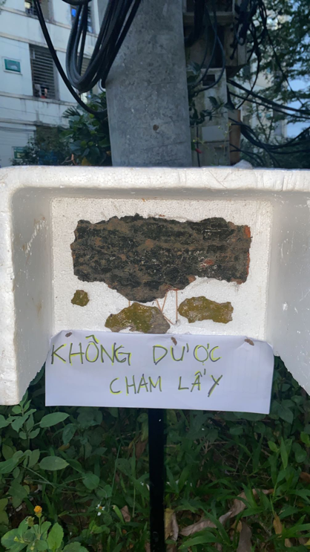
- Time: 18:22 pm
- Motorbike: 21
- Car: 4
- Truck:
- Lichens Number 2
- Picture 4:
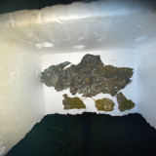
- Time: 18:25
- Motorbike:29
- Car: 5
- Truck: 0

- Day Three (Date: 09/04/2023)
- Lichens Number 1
- Picture 5:
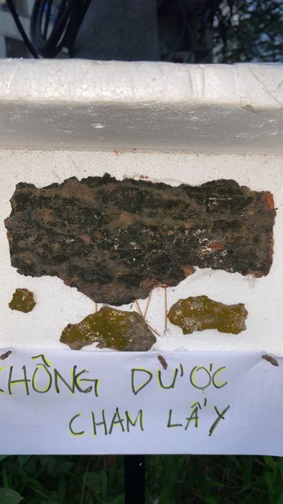
- Time: 18:35pm
- Motorbike: 35
- Car: 3
- Lichens Number 2
- Picture 6:
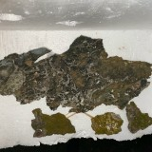
- Time: 18:45
- Motorbike: 29
- Car:4
- Truck:0

- Day Four (Date: 10/04/2023 )
- Lichens Number 1
- Picture 7:
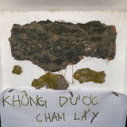
- Time: 18:15
- Motorbike: 35
- Car: 2
- Truck:0
- Lichens Number 2
- Picture 8:
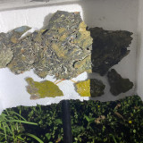
- Time: 18:40
- Motorbike: 32
- Car: 2
- Truck: 0

- Day Five (Date: 11/04/2023)
- Lichens Number 1
- Picture 9:
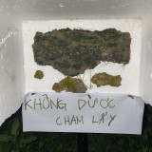
- Time: 18:45pm
- Motorbike: 28
- Car: 2
- Truck:0
- Lichens Number 2
- Picture 10:
- Time: 18:45
- Motorbike: 38
- Car: 3
- Truck: 0

- Day Six (Date: 12/04/2023)
- Lichens Number 1
- Picture 11:
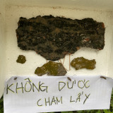
- Time: 17:10pm
- Motorbike: 40
- Car: 5
- Truck: 0
- Lichens Number 2
- Picture 12:
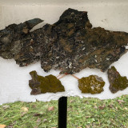
- Time: 17: 20pm
- Motorbike: 38
- Car: 3
- Truck: 0

- Day Seven (Date: 13/04/2023)
- Lichens Number 1
- Picture 13:
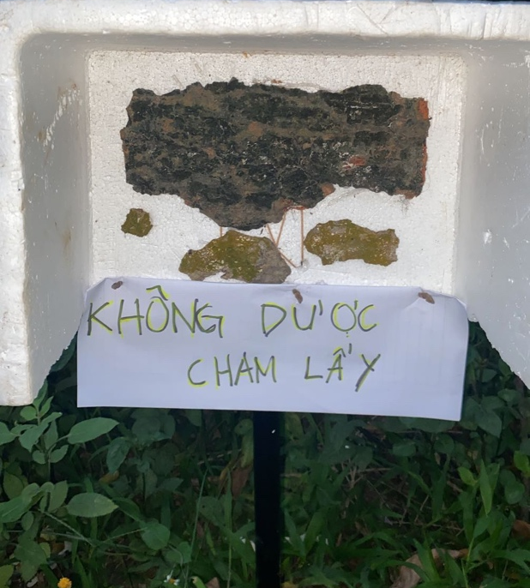
- Time: 18:35
- Motorbike: 33
- Car:2
- Truck:0
- Lichens Number 2
- Picture 14:
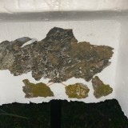
- Time: 18:38pm
- Motorbike: 27
- Car: 1
- Truck:0

- SPSS Report
The purpose of using Spss for this report analysis is to help the reader best understand the difference between the first location and the second location and it is easier to see the effect of the air pollutants on our lichens. For our Spss analysis, we are using two types of lichens that we are using for this report (Lichen’s species), two different locations that we are placing for the lichens (types of location), the different types of vehicles that we divided into three (number of vehicles), the time of monitoring the lichens (time in a day), the changing effect of lichens during 7days into three parts (effect). For the Kaplan-Meier analysis we are using time in a day for (Time), effect for (status), number of vehicles for (factor), types of location for (strata) and lichens species for (label of cases).
Picture: Case processing summary table of Kaplan Meier.
As the survival table shows that in location A the lichens are still alive while in location B within 7 days the two lichens are already dying. This factor causes by the places that we choose where for location A is less vehicles while for location B is more vehicles.
Picture: Survival Table and Means, Medians for survival Time.
Picture: Graphic of stratum Location 1
From our observation during the 7 days for location A(location1) the number of vehicles didn’t show that much compared to location B(location2) that’s why the changing of the color and the process of dying are quite slow compared to location B. As we can see from the graphic the survival rate from day one till day 3 lichens species 1 and 2 are still alive. The comparison between these could be seen from the survival table where in the location A species A and B still alive and just change in color. This factor also affects by the less transportation during the count’s day and time that’s why until 7 days both two species just change in color instead of dying.
Picture: Graphic of stratum Location 2
Different from location A above, in this picture, the graphic shows the same cum survival rate but as we mentioned before comparing location A and Location B, the second location B is having a greater number of vehicles since it’s close to the main crossroads between the dormitory of K3 and the central house. The comparison between these could be seen from the survival table where in location B species A and B already change in color within just three days while the lichen species A and B are still alive and just change in color. This factor also affects by the more using transportation during the count's day and time that’s why until 7 days for location B both lichens species A and B already dying.

- Conclusion
The overall air quality at the TUAF campus, specifically near the campus dormitory, is moderately clean. However, monitoring and control are required to rescue the effect of pollutants to create an environment of clean air at the University campus. From this report we can be assured that the lichens could help us, as students, to know more about how to monitor the air quality around us. During these 7 days, our group learned a lot about each type of lichen and the difference between lichens and fungi as well. To sum up this report our group conclude that lichens play an important role as an indicator for air quality, that could help us, as the society to be more known and understand the proper way to keep our air quality clean.

