WESTERN IDEAL BEAUTY CONSTRUCTION
(SEMIOTICS ANALYSIS IN PERFUME ADVERTISEMENT OF PT PRISKILA PRIMA MAKMUR)

Abstract
PT Priskila Prima Makmur is one of the biggest perfume producers in Indonesia. It has several famous perfume brands, such as Casablanca, Bellagio, Regazza, Camellia, Watchout, and Mary Jose. Although it is a genuine product of Indonesia, almost in all its advertisements use Western women as their model. In this research, the researcher took 6 of 22 videos of Priskila's advertisement which are, Casablanca Spray Cologne (2017), Regazza Mistery Man (2016), Camellia Fragrances of The World (2016), Bellagio Night in Paris (2014), Casablanca Teenage Dream (2013) and Regazza Spray Cologne (2011) as the subject. The purpose of this research is to know how the western bias constructed of the ideal beauty of women in the perfume advertisement of Priskila. This research used semiotics analysis of Roland Barthes to see how the western bias constructed in determining women beauty in the subjects. This research also used beauty myth theory by Naomi Wolf. The result of this study is the western construction in determining the women beauty in the advertisements video of Priskila can be found in the women model that shown in the six subjects through categories that have been made by researcher. The researcher determined three ideal women beauty constructed by western culture based on book entitle “The Beauty Myth” by Naomi Wolf. According to her, women who has the ideal beauty criteria are those who are young which can be seen from their unwrinkled and tight skin, have physical characteristics like Western women (white skin and pointed nose), and slim body which is have no excess fat in certain body parts (proportional).
Keywords : construction, advertisement, western, ideal beauty, semiotic
Abstrak
PT Priskila Prima Makmur merupakan salah produsen parfum terbesar di Indonesia yang menaungi beberapa merek parfum terkenal di antaranya Casablanca, Bellagio, Regazza, Camellia, Watchout, dan Mary Jose. Walaupun merupakan produk asli Indonesia, hampir di semua iklannya menggunakan model perempuan Barat. Dalam penelitian ini peneliti mengambil 6 dari 22 video iklan milik Priskila yaitu, Casablanca Spray Cologne (2017), Regazza Mistery Man (2016), Camellia Fragrances of The World (2016), Bellagio Night in Paris (2014), Casablanca Teenage Dream (2013), dan Regazza Spray Cologne (2011) sebagai subjeknya. Tujuan dari penelitian ini adalah untuk melihat bagaimana konstruksi bias barat pada kecantikan ideal perempuan dalam iklan parfum milik Priskila. Metode yang digunakan adalah melalui analisis semiotika Roland Barthes untuk melihat bagaimana konstruksi bias barat dalam menentukan kecantikan perempuan dalam subjek. Penelitian ini juga menggunakan pendekatan mitos kecantikan oleh Naomi Wolf. Hasil dari penelitian ini adalah konstruksi bias barat dalam menentukan kecantikan perempuan dalam video iklan Priskila dapat ditemukan dalam model perempuan yang ditampilkan dalam keenam subjek melalui kategori yang telah dibuat peneliti. Peneliti menentukan tiga kecantikan ideal perempuan yang dikonstruksikan oleh budaya barat berdasarkan buku “The Beauty Myth” oleh Naomi Wolf. Menurutnya, perempuan yang memenuhi kriteria cantik ideal adalah mereka yang berusia muda yaitu dilihat dari kulitnya yang kencang dan belum keriput, memiliki ciri fisik seperti perempuan barat (kulit putih dan hidung mancung), dan bertubuh langsing yaitu tidak memiliki kelebihan lemak pada bagian-bagian tubuh (proporsional).
Kata kunci : konstruksi, iklan, bias barat, kecantikan ideal, semiotika

INTRODUCTION

Advertising is one form of non-personal communication paid by the sponsor by using mass media and aims to persuade and influence the audience (viewer, listener or reader) (Wells, 1996). Meanwhile, according to Hasan Shadly in (Umi Lasminah 2011) defined the advertisement as: "A form of notification of the supply of goods or services to the public with the intention, directly or indirectly, to help offer merchandise, find employment or labor and so on. The ads are generally broadcasted on television shows, cinemas, newspapers, magazines, bulletin boards, radio, and so on". From some understanding above, can be concluded that advertising is a message or information that offers products or services for audiences published through mass media. Ads are published through a variety of media. Starting from print or electronic media. For example is television.
Advertisement not only offers its products, but offers a culture, an image. Advertisement as a propaganda tool of the popular culture spreads. Popular culture or so-called mass culture is defined as a relatively standardized cultural product, uniformed to be consumed by many people. Ads are also referred as a popular cultural reflection and forms a popular culture. Advertisement forms a popular culture /mass culture, for example in 1960s, the use of perfume as a popular culture started from the soap ads in America, after which the perfume industry began to spread (Aprilia, 2005).
Talking about advertisement, can't be separated from model. Ibrahim (ed) in Aprilia (2005) said that most ads use women models. About 90% of advertising uses women as a model. According to Tomagola quoted Lury (1998) and Miranti (2005), divided women image into five types that often appear in ads, one of which is the image of 'pergaulan' image that describes women want to be accepted in certain social environments. Women need to apply cosmetics and accessories to look attractive they are more confident and accepted in their social interaction.
The cosmetic advertisement can presents how the ideal women's beauty in society (Bjerke & Polegato, 2006), so the society considers that beautiful women are women who has characteristics as shown on advertisement. The ideal women's beauty that presented in advertisement was influenced by the western culture. Western culture here is the culture that comes from countries in Europe and America. The standard of ideal beauty that has become universal comes from the dominance of western culture such as rounded eyes, tapered face, sharp nose, and others (Kim in Yan and Bissel (2014).
Examples of beauty product advertisements (cosmetics) that use women models are perfume products from PT Priskila Prima Makmur, one of the biggest perfume producers in Indonesia. Quoted from the official website of Priskila, www.priskila.co.id brand under the auspices of this company is Casablanca, Regazza, Camellia, Bellagio, Watchout, and Marie Jose. Where many of them are famous perfume brand in Indonesia. In most of its product advertisements Priskila use more women models raised than men. It can be seen through the number of scenes in advertisements that dominated by women.
According to research by Bicalho (1993) entitled "The Art of Seduction: Representation of Women in Brazilian Silent Cinema", the representation of women is constructed by film narratives that transform women into subjects as well as seduction objects. The actresses are framed by cameras and translated through cinematography to attract the attention of audiences with images built from a masculine perspective. Laura Mulvey in her article "Visual Pleasure and Narrative Film" quoted by Bicalho (1993), said that cinematographic metaphors transform women into objects of gaze. Mulvey argues that the image of this feminine is built by cinema. Based on the research, the similarity with this research is analyzing image of woman formed by mass media with different subject that is in this research is video advertisement while that research is about cinema/film.
The construction process of meaning is related to semiology or the process of indicating (Yulidya, 2014). Saussure in "Course in General Linguistics", defines the term semiology/semiotics as "the study of the sign's role as part of social life" (Fiske 1990). Roland Barthes continues this Saussure thought with more emphasis on text interaction with personal or cultural experience of its users. Barthes's thought was to be known as "order of signification", including the term he developed, namely denotation (dictionary meaning) and connotation (the meaning that arise from cultural and personal experience). Therefore, this research will use semiotics method of Roland Barthes to analyze the sign meaning in advertisement.
In this study, researchers will use some video advertisement of PT Priskila Prima Makmur sourced from Priskila’s official youtube channel (www.youtube.com/user/PriskilaPrimaMakmur) as the subject of research. Some of these advertisement videos are Casablanca Spray Cologne (2017), Regazza Mistery Man (2016), Camellia Fragrances of The World (2016), Bellagio Night in Paris (2014), Casablanca Teenage Dream (2013), and Regazza Spray Cologne (2011) . Researchers consider these advertisements are interesting to be studied because beside Priskila is one of the largest beauty products company in Indonesia, most of their advertisements products have similar advertising concepts. Each advertisement always uses the physical attractiveness of women to attract the attention of consumers.
In line with the previous research entitled “Representasi Sensualitas Perempuan Dalam Iklan (Analisis Semiotika Roland Barthes Terhadap Iklan Parfum Axe Versi Heaven on Earth di Televisi)” by Padila (2013), where both uses Roland Barthes's semiotic method to analyze the symbols meanings in it. While the difference lies in both research's object and subject. Padila's research emphasizes the sensuality element shown in advertisement while this research aims to reveal how the women's ideal beauty in advertisement. This research's subject is the parfume advertisement of PT Priskila Prima Makmur while Padila's used Axe version Heaven on Earth advertisement as the subject.
In addition, this research also refers to a journal entitled "Post-Feminism And Specialized Media: A Content Analysis Of Cosmopolitan Headlines" by Crusmac (2013). The journal about theory of post-feminism through the analysis of Cosmopolitan magazine (one of the best-seller women's magazines in the world) constructs that a beautiful and independent woman is determined by the fashion they wear. Both of these researches are studying women in mass media only through two different media, which is this research use advertisement in form of video (electronic media) while in journal use magazine (print media) as its subject. Based on explanation above, the problem formulation that emerged in this research is how the western construction on the ideal women's beauty in perfume advertisement of PT Priskila Prima Makmur.

LITERATURE REVIEW

  - Advertisement in Mass Media

Advertising is defined as message that offers a product addressed to the society through a medium (Kasali, 1995). Advertising aims to influence the product's audience or services offered by company. Advertisements can't be separated from the involvement of model to get audience's attention. There are two factors why women become involved in advertising (Widyatama, 2005). First, woman is a big market in industry. Second, women believed to be able to strengthen advertising messages. Women are considered as elements of advertising that have selling's factors so using women in advertisement will bring a lot of advantages. For men the presence of women is a necessary condition to show their ability. For women themselves, women in advertisement become the self actualization that represents their identity. In addition women with sexual attraction became one of the mainstay of advertisement to attract the attention of its communications target (Wolf, 2002).
Fernandez (2011), in his research entitled “Komodifikasi Perempuan dalam Iklan Televisi” showed that important positions in economic and governmental institutions, their economic policies are dominated by men. In his research described the Marxism's feminist perspective judge women always try to look attractive sexually so the women body is often used as attraction in advertisement.

  - Woman in Advertisement

The frequently of young women portray in advertisement, young women have created the foundation for accepted gender roles in advertisement (Stern, 2004). Stern and Mastro (2004) found that women in advertisements described as having a body that is below the average body of women in general whereas men have average body. The size of the woman body shown in the advertisement is not the size of women's body in real life while the size of men's body corresponds to the size of men's body in general. In MTV advertisment studied by Stern and Mastro, women displayed using minimal and sexy clothes. The overall picture advertised by this advertisements is describe the women's body as a sexual object that should be used to get and attract audience's attention (Stern and Mastro, 2004). Quoting from journal entitled "The Art of Seduction: Representation of Women in Brazilian Silent Cinema", the women representation is constructed by film narratives that transform women into subjects as well as seduction objects.
In Indonesia itself, in the new order era the image of women in advertising is always connected with the household. Happy women are housewives who have made their husbands and children happy. Meanwhile, after the New Order era, the figure of women in advertisements more accentuate the figure of skilled and professional (Noviani, 2012).
Laura Mulvey (1989) in "Visual and Other Pleasure" said that cinematographic metaphors transform women into male gaze. According to Mulvey, the camera screen is identified as men eyes. Mulvey in a journal titled "Gender And The Action Film" by Hajarah & Briandana (2013) argued that the narrative structure in classical Hollywood put the position of man characters more active and strong, while women more passive and only become man's object desire. So the control on this male gaze according to Mulvey was present women as a picture or spectacle. The research result on Salt (2010) in that journal, found although the film is about woman masculinity in action films, still, camera shooting leads to woman sexuality. Camera shooting centers on the breast, thighs, buttocks and lips to provide an object of spactacle to audience. According to explanation above can be said that woman in advertisement only used as a spectacle and exposed the appeal of her sexuality. That research and this research that will be conducted by researcher both analyze about portrayal women in the subjects. While the difference between the two lies in the subject of study. Research by Hajarah and Briandana analyzed the films while this research used advertisement as the research subject.

  - Ideal Beauty Construction in Advertising

Berger and Luckman in Manuaba (2008) defined social construction as a social process that occurs through interaction among individuals or groups, in which the interaction created the reality that they have and experience together constantly. Construction also can't be separated from various society's social conditions (Strinati, 2007).
Children's fairy tales has already constructed the women's ideal beauty (Spade, et al, 2010). Brothers Grimm, author of the world-famous fairy tales Cinderella, Snow White, Sleeping Beauty, Rapunzel, and others always emphasize physical attractiveness in his story. In fairy tale always portrayed the figure of beautiful princess has white skin, comes from the top economy class, and has noble character (Baker-Sperry and Grauerholz, 2003). From that statement can be concluded that the construction of women's beauty has been implanted in the society since childhood.
From here the perception of beautiful women is perpetuated by mass media. According to Polivy and Herman in Yan and Bissel (2014) women presented information constantly in mass media so reinforce the construction of beauty through the models and actresses featured in it. Ideal beauty contents in the western media that have spreaded to world-wide society through globalization more strengthen the media-made beauty constructs (Coward, Yan and Bissel (2014) .The development of industrialization and consumerism culture in Western countries quickly spread to different parts of the world, forming a new ideal body image for women (Featherstone in Bestiana (2012).
Kasiyan (2012) said in Indonesia, women's body image in the media leads to the western women body shape due to the globalization of ideology. The women construction by media has led to the women's ideal beauty of Indonesian women that embracing Western culture. According to Naomi Wolf (2002) in her book "The Beauty Myth" beautiful women are women who classified several categories, including young women, having physical characteristics like Caucasian women (which are white skin and pointed nose), and having slim body. In her book, Wolf said that black, brown, and white skin women in America face the beauty myth. They want to be the perfect woman which is have a tall, slim, and white body. This is caused by western mass media that portray such women so it form a beauty myth that beautiful women is who have these characteristics. Wolf also considered that cosmetics industries became the source of a beauty myth that created by patriarchal system to control women.
Ideal beauty discourse become a commodity that is never run out by media. This ideal beauty is constantly defined and redefined over and over the exploitation of discourse on beauty. One party who has interest in women's beauty discourse is a cosmetic product. Cosmetics producers will always try to make new concepts about how women's ideal beauty in society (Puspa, 2010), so the woman models of advertisements that portray by beauty products producers will reinforce ideal beauty construction in society. So the purpose of this research is to analyse the women's ideal beauty constructions in Priskila's advertisement videos.

  - Semiotics in Audio Visual

In studying the meaning of a sign or symbol used semiotic analysis method (Sobur, 2016). The purpose of semiotics is to analyze how social structures can be formed (Hartman, 2017). According to Barthes, the sign consists of signifier (penanda) and signified (petanda) which known as denotation and connotation, but in connotation meaning Barthes add myths element. Signifier is the meaning of text according to what is visible, while the signified is meaning of the text based on the existing culture where the text was created (Marliana, 2013). Denotative also said as a fixed objective meaning, whereas connotative refers to subjective and varied meanings. Its function is to justify the dominant values prevailing in a certain period. Barthes asserted that denotative is the first level of meaning system while connotative is the second level of meaning system (Sobur, 2016).
The concept of myth has three dimensional patterns, namely signifier, signified, and sign. In his book entitled "Mythology", Roland Barthes (2006) said that in daily language, the signifier is used to reveal the signified. It's different with semiology's term it isn't just dealing with the two terms of signifier and signified but there are three different terms namely signifier, signified, and sign. Sign is the unity of the two previous terms. Myth is a specific system because it formed from a series of semilogical system which are signifier and signified systems that make myth become the second-level of semiological system. According to Barthes myth is the language. Myth is a story to understand the aspects of reality used by cultural societies (Barthes in Sabatini, 2013).
This research refers to an earlier research entitled “Representasi Sensualitas Perempuan Dalam Iklan (Analisis Semiotika Roland Barthes Terhadap Iklan Parfum Axe Versi Heaven on Earth di Televisi)” by Padila (2013), where both research uses Roland Barthes's semiotics method to analyse the symbols meaning in the subjects, and the difference lied on research’s subject and object which is Padila's examined the sensuality of women in his subject which is Axe Heaven on Earth advertisement, while this research examined the women's ideal beauty construction in the subjects which are Cologne Casablanca Spray (2017), Regazza Mistery Man (2016), Camellia Fragrances of The World (2016), Bellagio Night in Paris (2014), Casablanca Teenage Dream (2013), and Regazza Spray Cologne (2011) advertisement.
Beside that there was research entitled “Isu Ras dan Warna Kulit dalam Konstruksi Kecantikan Ideal Perempuan” by Puspa (2010) where the research also analyzes the women's ideal beauty construction using Barthes semiotics, but the difference lied in the research subject. Where the research used advertisement of tanning lotion Wet n Wild, Magic Tan, Jergens, and Aveeno while this research using perfume advertisement of Priskila.

METHODS

This research is found in the level of mass communication in which will examine ads that are socialized or communicated to audiences through mass media. This research uses qualitative analysis approach. According to Mulyana (2003) qualitative research does not refer to evidence on mathematical logic, numerical principles, and statistical methods and aims to maintain the form and content of human behavior also to analyze its quality rather than converting it into quantitative entities.
The population of this study is the total of product advertisement of PT Priskila Prima Makmur, which amounted to 22 videos, while the samples are some advertisement of PT Priskila Prima Makmur that is ad of Casablanca Spray Cologne (2017), Regazza Mistery Man (2016), Camellia Fragrances of The World (2016), Bellagio Night in Paris (2014), Casablanca Teenage Dream (2013), and Regazza Spray Cologne (2011).
The sampling technique that use in this research is purposive sampling. According to Pujileksono (2016) in "Metode Penelitian Komunikasi" purposive sampling techniques determine the sample based on a particular purpose. Researchers consider something that has and can provide information needed by researchers to conduct research. The information in question is a video which in it displays lots of women scene. Researcher chose the samples with the consideration that the six video advertisements are video that most recent of Priskila’s various brands. From the total of 22 videos, researcher found there were only 18 videos portrayed women models. Then the researcher took 6 videos sample because researcher found a repetition of the same concept which is preparing to go to a party in each advertisement and the 6 videos researcher took from the most recent video of some of Priskila's brand.
The subject in this research is the ads of Casablanca Spray Cologne (2017), Regazza Mistery Man (2016), Camellia Fragrances of The World (2016), Bellagio Night in Paris (2014), Casablanca Teenage Dream (2013), and Regazza Spray Cologne (2011) that sourced from the official youtube channel of PT Priskila Prima Makmur (www.youtube.com/user/PriskilaPrimaMakmur), as the producer of the product. While the object under study is the women's ideal beauty construction in the video advertisement. Researcher chose 6 of 22 videos of the advertisement total number because those six advertisements were the most recent videos of Priskila and more show women models in it. Later researcher will analyze the advertisements through its visual aspect.
This research uses documentation method and literature study as data collection technique. According to Yusuf (2014), the document is a record or work of someone in the past. Can be written as text, artefacts, pictures or photos.In this research, researcher will collect documentation from the Internet (from Priskila's Youtube Channel). Data collection techniques through literature study is a method of collecting data from books, magazines, newspapers, previous research, and other literature so as to form the literature review (Arikunto, 2006). In this research, researcher conducted literature study from books and also some previous research.
The unit that will be analyzed in this research is per-sequence. According to Joseph Mascelli (2010) in the book titled "The Five C'S of Cinematography: Motion Picture Filming Techniques Simplified", in cinematography known 3 terms in dividing images that are shot, scene, and sequence. Shot is formed when the 'rec' button on the camera is pressed (picture starts to be recorded) until the button is pressed again (the image is finished recorded). Scene is the taking picture that distinguished by place or event setting. Scene consists of several combined of shots. While the sequence is a series of scenes that merged into one. Sequence begins and ends with a transition. Data analysis techniques used are qualitative analysis techniques through semiotics Roland Barthes method to find out the ideal beauty construction of women the subjects. According to Barthes (2002), myth in his semiotic is a specific system because it formed from a series of semilogical system which are signifier and signified systems that make myth become the second-level of semiological system.
The technique of data validity that will be used in this research is the triangulation of theory technique. Triangulation of theory is a technique for testing the validity of data through the decoding of patterns, relationships, and includes an explanation that emerges from an analysis to find a theme or explanation which will later be used as a comparison (Bungin, 2008: 265). According to Lincoln and Guba in Moleong, the purpose of using triangulation theory is to compare information about the same things obtained from various parties, in order to guarantee the level of data credibility. It is also to prevent subjective dangers. Therefore, this research will use the comparison of beauty myths by Naomi Wolf and semiotics by Roland Barthes.

RESULT AND DISCUSSION

To analyze the ideal beauty constructions in the subjects, researcher coded the six video advertisements of Casablanca Spray Cologne (2017), Regazza Mistery Man (2016), Camellia Fragrances of The World (2016), Bellagio Night in Paris (2014), Casablanca Teenage Dream (2013), and Regazza Spray Cologne (2011) uses Roland Barthes's semiotics theory like researcher have described in the research method chapter. From the coding results that have been obtained will be reduced and selected then will be categorize in the appropriate category made by researcher. The categories created refer to the book "The Beauty Myth" by Naomi Wolf (2002). Researcher found the women's ideal beauty construction in Priskila's advertisements as follows:

  - Youth As Ideal Beauty Construction
Youth and virginity became measurement of women's beauty. Since women grow over time, aging women are considered as not beautiful women anymore (Wolf, 2002). Therefore, women who are still young considered women who have ideal beauty. According to Julian (2016) age is always associated with the phrase "tight skin", which is usually not owned by the old agewomen. Therefore, young women are always identical to have tight skin. In addition Hariyanti et al (2015) said that the skin moisture that decreases along with aging causing the skin becomes dry and dull. Dry skin is a common cause of skin wrinkles in old age. So youth is identical with having tight skin and not wrinkled skin.
In the six subjects, researcher found that tight skin and not wrinkled women used as models in advertisement. Construction of young women researcher found on all subjects, Casablanca Spray Cologne (2017), Regazza Mistery Man (2016), Camellia Fragrances of The World (2016), Bellagio Night in Paris (2014), Casablanca Teenage Dream (2013), and Regazza Spray Cologne (2011).
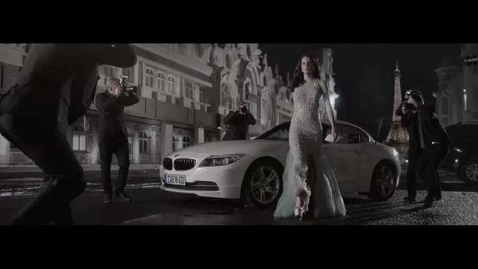
Denotative Signifier | Denotative Signified
Tall, tight and unwrinkled-skinned, pointed nose woman, wearing high heels, wearing long white dress and there was 4 men holding cameras. She was walking toward a building. | A caucasian-faced woman that has tight and unwrinkled skin was walking and photographed by 4 men
Denotative Sign
The Casablanca Spray Cologne model is a young caucasian woman that has unwrinkled and tight skin. She was walking to party place and there were 4 photographers who were taking her pictures
Connotative Signifier |  | Connotative Signified
A caucasian young woman in Casablanca Spray Cologne's was walking along with 4 men photographers who photographed her. She was about to attend a party. |  | Woman in Casablanca Spray Cologne's is a beautiful woman
Table 4.1.1. Casablanca Spray Cologne’s Advertisement (2017)
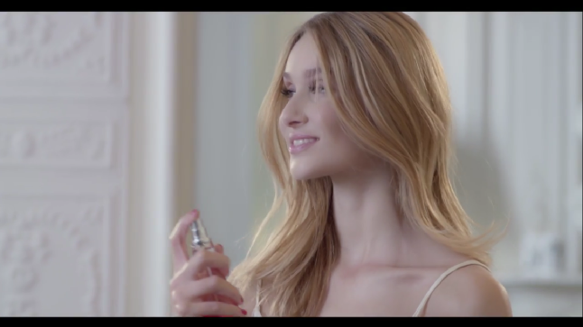
Denotative Signifier | Denotative Signified
a shoulder-length blonde hair, white, tight and unwrinkled skinned woman after waking up then take a bottle from her dressing table and bring it to the window and spray it | a blonde, tight and white-skinned woman was spraying Regazza perfume after waking up
Denotative Sign
A young woman in the Regazza Mystery Man's was spraying perfume on her body
Connotative Signifier |  | Connotative Signified
A Regazza Mystery Man's model is spraying Regazza perfume into her body |  | Women in the Regazza Mystery Man advertisement is beautiful women according to advertisement
Table 4.1.2. Regazza Mistery Man’s Advertisement (2016)

Denotative Signifier | Denotative Signified
Blonde-haired, pointed-nosed, tight-skinned without wrinkled woman, wearing a pale pink sleeveless dress with long above the knees on her way walking down the Eiffel tower | A tight-skinned and unwrinkled Caucasian woman walking in Paris wear an open pale pink dress
Denotative Sign
A young Caucasian woman in Camellia Fragrance of the World advertisement dressed in pale pink, wearing heels and she was walking in Paris
Connotative Signifier |  | Connotative Signified
Camellia Fragrance of the World advertisement model is a young Caucasian woman and she was walking in Paris wearing a pale pink dress |  | Camellia Fragrances of the World advertisement model is a young Caucasian woman. A long, knee-length and open shoulder dress is more show up her tight skin

Table 4.1.3. Camellia Fragrances of The World’s Advertisement (2016)

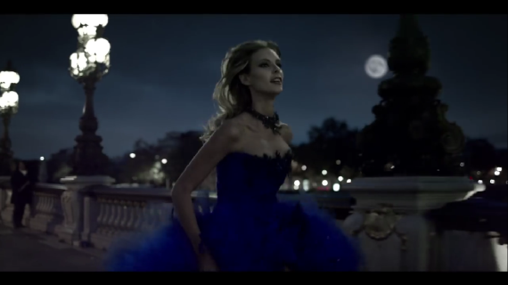
Denotative Signifier | Denotative Signified
A blond-haired, white, tight and unwrinkled skinned woman wearing a sleeveless blue dress with her fluttering hair and she was at someplace in Paris | A woman has tight skin without any wrinkles and caucasian face is running slowly while lifting her skirt
Denotative Sign
A young caucasian-faced woman is a Bellagio Night in Paris advertisement model. She was running slowly to chase something.
Connotative Signifier |  | Connotative Signified
A young woman in Bellagio Night in Paris advertisement was running toward something and wearing a blue dress that showed her arm |  | The women that shown on Bellagio Night in Paris advertisement are beautiful women.

Table 4.1.4. Bellagio Night in Paris Advertisement (2014)

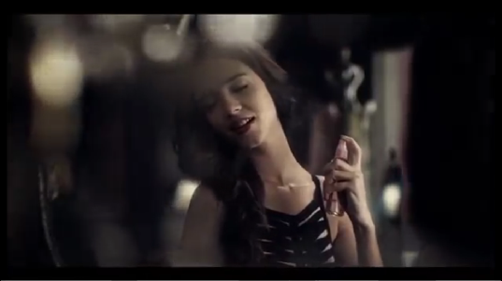
Denotative Signifier | Denotative Signified
A woman that has long-hair, white and tight and unwrinkled-skin was wearing a tight black dress in her room, taking her bag from the bed then taking a bottle from the table and spraying it on her body | A tight and unwrinkled-skinned Caucasian woman holding a perfume bottle and spraying it to her neck before leaving her room
Denotative Sign
A young woman in Casablanca Teenage Dream advertisement is spraying Casablanca perfume to her neck
Conotative Signifier |  | Conotative Signified
Woman model in Casablanca Teenage Dream's is using perfume |  | Casablanca Teenage Dream’s model is a beautiful woman.

Table 4.1.5. Casablanca Teenage Dream Advertisement (2013)

Denotative Signifier | Denotative Signified
Unwrinkled and Tight-skinned, shoulder-length haired woman was wearing a long sleeveless red dress standing in front of a mirror with another woman behind her | A tight and unwrinkled-skinned Caucasian woman was trying a sleeveless red dress assisted by another woman
Denotative Sign
A young woman in the Regazza Spray Cologne's was fitting on a sleeveless red dress
Connotative Signifier |  | Connotative Signified
A young woman model in Regazza Spray Cologne's was trying a red dress |  | The woman model used in the Regazza Spray Cologne advertisement is a woman who is considered as beautiful

Table 4.1.6. Regazza Spray Cologne Advertisement (2011)

From the analysis of six subjects above researcher found the myth that shaped by Priskila us women who fall into ideal beauty category is the young women. This young woman can be seen from her tight and unwrinkled skin. According to Naomi Wolf (2002) women's beauty constructed in society is seen from their physical appearance, one of them is to have a young age. Characteristics of young women according to Julian (2016) is a woman who has a tight skin and according to Hariyanti et al (2015) also has skin that is not dry (wrinkles).
This youth as an ideal beauty is constructed by western culture. Mass media also have important role in the construction of this beauty. Wolf (2002) also stated that through mass media the construction of beauty is always reproduced. In line with Wolf, Laura Mulvey in Kellner (2006) added that women are unconsciously perceive what is displayed by media is the ideal form of a beautiful woman. Mulvey revealed women unconscious through psychoanalysis approach. Through a psychoanalytic approach, every human being thinks and performs an action that is driven by emotional and psychological factors from within and beyond one's consciousness. (Baran and Dabis in Handayani (2017)). This causes women want tocome as shown by what media presents.
The example is the use of young models in television and magazine advertisements. As represented in this Priskila's advertisement. The entire advertisement used young women models, which can be seen from their tight skin. This reinforces the construction of young women who are considered as women's ideal beauty. Therefore, as what Wolf (2002) said young women become worried to look old. and older women are afraid of young women.
In "The Beauty Myth" adultery of age by women who crave youth (by removing wrinkles on the face) make cosmetics producers ruling over age. But basically it's just a false claim. Buddy Wedderburn (Unilever biochemist), Annita Roddick (owner of cosmetic brand The Body Shop) also said that nothing beauty product that could make us younger. Before the industrial revolution, the average woman did not have same definition of what is called beautiful. Different after the industrial revolution, because of increasing industrialization, the new ideal physical standards of beauty distributed massly.

  - Caucasian Race’s Genetic Characteristic as Ideal Beauty Construction

In "The Beauty Myth", Wolf (2002) Colored skin people is considered as "abnormal". The term colored skin by Show Racism the Red Card refers to black people. And what means by normal here is white people. In addition, the beautiful category according to the beauty myth is also a nose that is owned by Westerners, which is a pointed nose. The researcher found that beauty construction in Casablanca Spray Cologne (2017), Regazza Mistery Man (2016), Camellia Fragrances of The World (2016), Bellagio Night in Paris (2014), Casablanca Teenage Dream (2013), and Regazza Spray Cologne (2011).

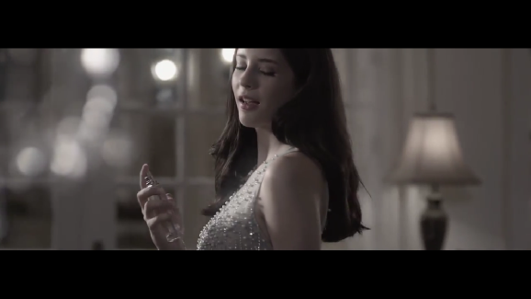
Denotative Signifier | Denotative Signified
A white and pointed-nosed woman, walking to a table and taking a bottle and spraying it on her body, angle shot from the side | A white and pointed-nosed woman was spraying perfume on her body
Denotative Sign
A white-skinned and pointed-nosed model of the Casablanca Spray Cologne is using perfume
Connotative Signifier |  | Connotative Signified
The woman model in Casablanca Spray Cologne's was spraying perfume on her body |  | A model in Casablanca Spray Cologne has white skin also pointed nose and she is considered as beautiful
Table 4.2.1. Casablanca Spray Cologne Advertisement (2017)

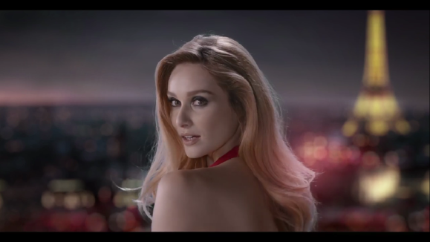
Denotative Signifier | Denotative Signified
A white-skinned and pointed-nosed woman with an openned back dress, stood on the balcony and turned to the man behind her | A white-skinned and pointed-nosed woman was waiting for someone and then stares at the man behind her
Denotative Sign
A white woman and has pointed nose was looking back to see someone coming
Connotative Signifier |  | Connotative Signified
The model in the Regazza Mystery Man's was staring at someone behind her |  | A beautiful woman in Regazza Mistery Man's was staring at someone in behind her who saw her from far

Table 4.2.2. Regazza Mistery Man Advertisement (2016)

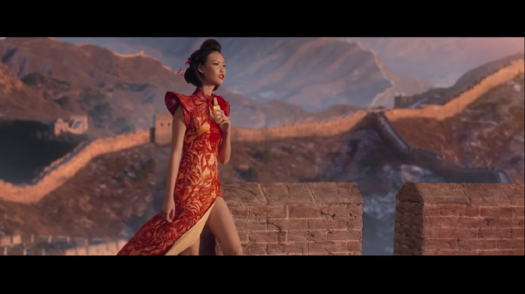
Denotative Signifier | Denotative Signified
A slant-eyed, black haired, white-skinned, small noses woman wearing long red dress that show her legs, walking on a Great Wall China and then take a bottle from the top of the wall | A white Chinese woman using an open dress were walking on the Great Wall China and holding a perfume bottle.
Denotative Sign
Chinese women as Camellia advertisement model were holding Camellia perfume bottles while walking on the Great Wall China.
Connotative Signifier |  | Connotative Signified
A white Chinese woman in a Camellia's advertisement were walking on a Great Wall China while holding Camellia's perfume |  | Camellia's advertisement model wear an open dress on legs to expose her white skin

Table 2.2.3. Camellia Fragrances of the World Advertisement (2016)

Denotative Signifier | Denotative Signified
Blond-haired, white-skinned, pointed nose, wearing a long sleeveless blue dress over the knees, with heels, and with Eiffel tower background, were running while lifting her dress | A Caucasian woman on an open blue dress were running in Paris
Denotative Sign
A Caucasian woman in Bellagio Night in Paris advertisement wearing a sleeveless blue dress was and walking in Paris
Connotative Signifier |  | Connotative Signified
The Bellagio Night in Paris advertisement model was a Caucasian woman and she was running in Paris wearing a blue dress |  | Bellagio Night in Paris advertisement model is a Caucasian woman, a woman from white race with pointed nose. The sleeveless and long dress above the knee exposed her white skin

Table 4.2.4. Bellagio Night in Paris Advertisement (2014)

Denotative Signifier | Denotative Signified
A white-skinned, pointed-nose woman wearing a black open-sleeved dress, walking against window to take her bag from the bed and perfume on the table and spray it to her body | A Caucasian woman was walking away of the window to go out
Denotative Sign
A Caucasian woman in a Casablanca Teenage Dream advertisement in black open arms dress was walking out of her room
Connotative Signifier |  | Connotative Signified
A Casablanca Teenage Dream advertisement model is a Caucasian woman and were walking away from the window to get out of her room |  | Casablanca Teenage Dream advertisement model was a white Caucasian women with pointed nose. Her sleeveless black dress exposed the white skin she has

Table 4.2.5. Casablanca Teenage Dream Advertisement (2013)

Denotative Signifier | Denotative Signified
A white-skinned, pointed nose woman opened her nightgown that left a white dress above the knee with her back open then took a bottle from the desk and stood in front of the mirror while spraying it | A white-skinned and pointed-nosed woman was spraying perfume into her body while reflecting in her room
Denotative Sign
The white woman in the Regazza Spray Cologne advertisement was using Regazza's perfume in front of the mirror in her room
Connotative Signifier |  | Connotative Signified
Regazza Spray Cologne's model was a white-skinned and pointed-nosed woman and using perfume in front of a mirror in her room |  | Regazza Spray Cologne's model was a Caucasian woman wearing open back dress to show her white skin

Table 4.2.6. Regazza Spray Cologne Advertisement (2011)

Based on analysis above researcher found that these advertisements form a myth that women are considered beautiful when having physical characteristics like Caucasian women, have white skin and pointed nose. Pointed nose mostly owned only by Westerners who come from the Caucasian race. In other words, beautiful women are those who have physical characteristics like Caucasian women. Priskila ads can be seen dominated by the presence of women models that didn't have Indonesian face. They have pointed nose and white skin. Although there are actually some Priskila ads that use Indonesian women models, their characteristics also meet the beauty classification as Caucasian women have. Actually researcher also found an oriental/Chinese-faced model in one of Priskila's advertisement which is "Camelia Fragrances of The World". The model has narrow eyes, small nose, and white skin. Although she is not of the Caucasian race but has some ideal beauty traits according to beauty myths as in the previous category, young and white skin.
In her book entitled "The Beauty Myth" Naomi Wolf (2002) colored skin (non-white) is considered abnormal. In other words, white skin people are considered normal. White skin is associated with the perception of beauty because white is considered a superior race that is Caucasian, so having white skin is considered as an ideal beauty. This is shown in Priskila's advertisements which are dominated by the presence of Caucasian women. In addition, white skin is also constructed as a norm (Prabasmoro, 2006). White skin stigma that considered beautiful is inseparable from the colonization of the past that privileged white race. Where the white at that time were considered as a more respectable, educated, and higher social status races (Yuliyanto, 2007). Can be seen from the six advertisements of Priskila, where the entire advertisement's model using white women.
In "The Beauty Myth" the appearance of this beauty standard makes the rampant cosmetic surgery done by women. Women make changes to certain body parts to look beautiful. Western women also done cosmetic surgery surgery on the nose that perceived as less perfect and shows the character of a non-white nose, although the improvement is only a little. Women have to suffer in cosmetic surgery to become beautiful. Women become cosmetic surgical candidates for being perceived as inferior, judgments by other women also excommunicate them. They have to endure the pain of surgery to get the desired beauty.
Besides, Indonesian women have different types of skin color, not only white. This beauty standard is influenced by Western culture. Kasiyan (2012) said that in Indonesia, the women's body image in media leads to western women body shape due to the globalization of ideology. According to Wolf (2002) early spread of this standard is in the industrial revolution in Western countries that ultimately affect Indonesia.
Wolf (2002) also added that the image of women's beauty constructed by partriarchy's culture. This is similar with Laura Mulvey in Kellner (2006) that women are the sexual objects constructed by men from patriarchal culture in society. Laura Mulvey explained partriarchy culture shapes the image of women through the theory of psychoalnalysis. That women have unconsciously followed her. So with this unconsciousness women consider what the media display is the ideal form of a beautiful woman so they try to be as shown by the media that purpose is to become the object of the male gaze.

  - Slim as Ideal Beauty Construction
Beside the two things above, the standard of beauty constructed by the partriarchy hereditary is thebody size. As Naomi Wolf (2002) disclosed, in the beauty myths made by Western culture, beautiful women have thin body, in other words slim. According to Melliana in Khulsum (2014) the slim body isn't have excess fat on body parts (proportional), has a flat belly, firm breasts, curved waist, and staple butt. Slim body construction in Priskila's can be seen in the following analysis:
Denotative Signifier | Denotative Signified
Women with long legs, pointed noses, slim waist, wearing long white dress was walking toward a building and there was 4 men holding cameras, angle shots from the bottom | A slim caucasian woman was walking and photographed by 4 men
Denotative Sign
The Casablanca Spray Cologne's model is a slim, caucasian woman. She was walking towards a party place and there were 4 photographers who taking her pictures
Connotative Signifier |  | Connotative Signified
Casablanca Spray Cologne model was caucasian model that has slim body and she was walking followed by 4 men who photographed her. She was about to attend a party. |  | A slim Caucasian woman became the focus of men.Camera shot from the bottom to give impression to her long legs.

Table 4.3.1. Casablanca Spray Cologne Advertisement (2017)

Denotative Signifier | Denotative Signified
Women with long legs, pointed nose, slim waist, wearing a long flowering blue dress above the knee, carrying something white, walking on the sidewalk and crossing the highway | A slim caucasian-faced woman was crossing the street carrying shopping bag
Denotative Sign
A Regazza Mystery Man's model was a slim, Caucasian woman. She was crossing the street with a shopping bag
Connotative Signifier |  | Connotative Signified
A slim caucasian-faced Regaza Mystery Man's model was crossing the street carrying a shopping bag |  | Caucasian-faced woman wore a long shirt over her knee to show her legs that showing her slim body

Table 4.3.2. Regazza Mistery Man Advertisement (2016)

Denotative Signifier | Denotative Signified
Woman with brown hair, white skin, small waist curl, wear long red dress with open shoulder, running slowly with Red Square background | A slim Caucasian woman was running slowly by lifting her long skirt a little in Moscow
Denotative Sign
A Camellia Fragrances of the World model has a slim body was running in Moscow
Connotative Signifier |  | Connotative Signified
Women in Camellia's was a slim Caucasian and were running slowly wearing an open shoulders red dress |  | The Camellia advertisement model is a Caucasian dressed with open shoulders to show his white skin and slender shoulder. The small waist curve that seen from her tight dress at the waist, indicating that she has a slim body

Table 4.3.3. Camellia Fragrances of the World Advertisement (2016)

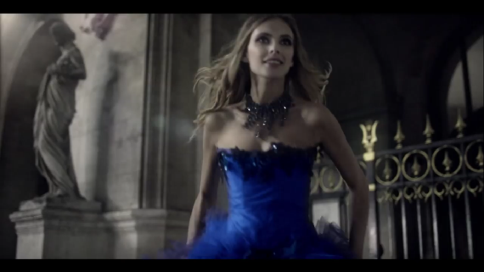
Denotative Signifier | Denotative Signified
A blonde, white-skinned, slim-armed woman wore a tight sleeveless blue dress, with hair fluttering backward as she ran a little in Paris | A slim Caucasian woman was running a little with lifted her long skirt up in Paris
Denotative Sign
A Bellagio Night in Paris model has a slim body was running slowly
Connotative Signifier |  | Connotative Signified
Woman in Bellagio Night in Paris advertisement who has Caucasian-faced and slim body was running wearing sleeveless blue dress |  | The tight dress exposes her flat stomach, which is it was slim body traits

Table 4.3.4. Bellagio Night in Paris Advertisement (2014)

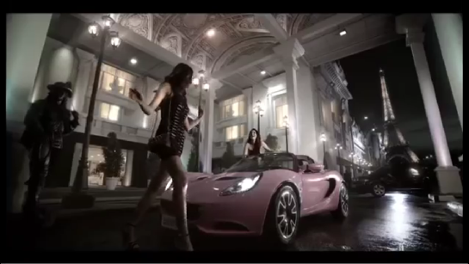
Denotative Signifier | Denotative Signified
A woman wore tight black shirt, with length over knees and open arms, waving her hand to other women and walking toward a car | The slim woman was walking and greeted her friend who picked her up with car
Denotative Sign
Casablanca Teenage Dream model was slim woman and walking towards a car
Connotative Signifier |  | Connotative Signified
A slim woman in Casablanca Teenage Dream's was walking to the car |  | The tight dress she wore showed her small body, and lenght dress above the knees with open arms indicated that she had small legs and slim shoulders. Slim shoulders, small legs and small hips shown slim body

Table 4.3.5. Casablanca Teenage Dream Advertisement (2013)

Denotative Signifier | Denotative Signified
Women wore pink open arm clothes, long above the knees, carrying a lot of bags in her hands were walking in the park then jump on the bed | A slim women were carrying a lot of shopping bags
Denotative Sign
The model in Regazza Spray Cologne's was slim woman and carrying shopping bags
Connotative Signifier |  | Connotative Signified
The slim woman in Regazza Spray Cologne's walking with shopping bags |  | The open-sleeved shirt worn by the model shown the slim arms and it lenght above the knee indicating that it has a small legs. Her slim shoulders and small legs show a slim body

Tabel 4.3.6. Regazza Spray Cologne Advertisement (2011)

Analysis of six advertisements explained about the myths formed by the advertisement that is women's ideal beauty is slim women which is have a proportionate body, curved waist, flat stomach. Before 1965, beautiful women were synonymous with "all-round" before finally emerging a skinny British model who appeared horrendous world at that time. After that the skinny body began to be loved by people. Beautiful women image when having a large body displaced by a new perspective, namely beautiful women are thin women. (Ella and Yepa, 2004). The slim woman model, according to BMI (Body Mass Index) is a thinly underweight category (Rader Programs in Bestiana (2012) .The BMI is a measure used to calculate proportionality of weight ratio with a person's height. Wolf (2002) said that the weight of fashion models has a margin of 23% less than women's weight in general.. This cause women want a thin body. By this standard, it increases eating disorder (deviant eating habits) and cosmetics into a fast-growing medical field (Wolf, 2002).
With the given of the global spread of beauty standards embrace Western culture, women are obsessed with thin bodies (Chung & Bissell, in Yan & Bissel, 2010). Wolf (2002) said the first obsession with this slim body is a phenomenon in America itself. Then it spread to Western Europe and Third World countries. This ideal beauty standard spreads along with the industrial revolution. The society was introduced to a slim women figure who is considered the ideal beauty through fashion, movies, and various types of advertising. Mass media create a slim woman image better than a fat woman. Slim woman are considered beautiful and beautiful is nice. In media, slim woman also often depicted with a figure who always has a handsome partner and always look happy (Bestiana, 2012). Wolf (2002) also said that women want to be beautiful because men want to have beautiful women. The desire of women to be seen by men is also inseparable from the role of mass media that represents the beautiful women as what men want. Laura Mulvey in Kellner (2006) explains that the representation of women in camera screens is actually only become the object of male spactacle or called male gaze. Laura Mulvey's male gaze theory suggests that the camera lens is likened as man eyes and woman in camera screens constructed by men, to be seen by men as objects rather than subjects.

CONCLUSION

From the six research subjects, the researcher found that in the six advertisement there is a Western construction on women's ideal beauty based on three categories that have been made by researcher. The six subjects fulfill the ideal beauty's category according to Western culture based on the beauty myth of Naomi Wolf (2002). In the video advertisements of Casablanca Spray Cologne (2017), Regazza Mistery Man (2016), Camellia Fragrances of The World (2016), Bellagio Night in Paris (2014), Casablanca Teenage Dream (2013), and Regazza Spray Cologne (2011) ideal beauty are constructed based on young age (having a tight skin and unwrinkles), genetic characteristics of western women (white skin, pointed nose) and slim body (lacking excess fat on some body parts (proportional)). Beside these three categories which refer to ideal beauty constructed by western culture, western bias here can also be found in the model used by Priskila in their advertisements. Although PT Priskila Prima Makmur is the originally Indonesian parfume's company, six subject are almost all Caucasian-faced models. Although in the Camellia Fragrances of The World (2016) advertisement there is an oriental-faced model (Chinese), but still its beauty is defined based on the ideal beauty according to western culture like the three categories. This research strengthen previous studies on women's ideal beauty constructed by mass media especially advertisement. The limit of this research is only focus on the construction of western bias in women's ideal beauty through the physical form of body so the suggestion for future research could add a focus on fashion semiotics in determining beauty.

ACKNOWLEDGEMENT
Alhamdulillah all praise to Allah, finally researcher complete this scientific publication. In the process of making this publication is inseparable from support of all parties around the researcher. On this occasion researcher would like to thank all those who always support until this research is done, without your support it is impossible for the researcher to reach this point. Special thanks are the researcher dedicated to the following parties:
- The main gratefulness, researcher pray all thanks to Allah who with grace always provide fluency for researcher in completing this publication.
- To researcher's family, Mr. Choirul Anas Dahlan, Mrs. Yulis Setyowati, grandmother, and sister and brother of researcher who always provide material and moral support for the completion of this research.
- To researcher's supervisor, Mr. Yudha Wirawanda, MA who patiently always guide and give direction to the researcher.
- To researcher's best friends Cika Dias Faradita, Elsa Vionita, Rini Kurnia Utami, and Dwi Bagus N who always give advices to researchers.
- For class X friends, Lala, Wendy, Cika, Khusnul, Luxy, Bagus, Syafiq, Zul, Ponco, Dafi, and Cahya for the sense of kinship that has been given in four years of researcher's study in UMS.
- To all UMS Communication Science lecturers who have shared their knowledge so may be useful for researcher's future.
- Thanks to other parties whose can't be mentioned one by one for all the support and pray for researcher.

REFERENCES
Books and E-books :
Barthes, Roland. 1983. Mythologies. New York: Hill and Wang (terjemahan Nurhadi dan A Sihabul Millah). 2006. Mitologi. Yogyakarta: Kreasi Wacana
Budiman, Kris. 2011. Semiotika Visual. Yogyakarta: Jalasutra
Bungin, Burhan. 2008. Penelitian Kualitatif. Jakarta: Kencana Prenada Media Group
Moleong, Lexy J. 2014. Metode Penelitian Kualitatif. Bandung: Remaja Rosdakarya
Mulvey, Laura. 1989. Visual and Other Pleasure. New York: Palgrave
Mulyana, Deddy. 2003. Metodologi Penelitian Kualitatif. Bandung : Rosdakarya
Nawawi, H Hadari. 1995. Metode Penelitian Bidang Sosial. Yogyakarta: Gadjah Mada University Press
Noviani, Ratna. 2012. Identity Politics in Indonesian Advertising. Yogyakarta: Kanisius
Priyatna, Pramasmoro. 2006. Kajian Budaya Feminis : Tubuh, Sastra, Dan Budaya Pop / Aquarini. Bandung : Jalasutra
Pujileksono, Sugeng. 2016. Metode Penelitian Komunikasi. Malang: Intrans Publishing
Sobur, Alex. 2016. Semiotika Komunikasi. Bandung: Remaja Rosdakarya
Spade, Joan Z; Valentine, Catherine (Kay) G. 2010. The Kaleidoscope of Gender: Prisms, Patterns and Possibilities (Third ed.). SAGE Pubication, Inc.
Widyatama, Rendra. 2005. Pengantar Periklanan. Jakarta: Buana Pustaka Indonesia
Wolf, Naomi. 2002. The Beauty Myth. New York: Harper Collins Publishers
Yusuf, Muri. 2014. Metode Penelitian: Kuantitatif, Kualitatif, dan Penelitian Gabungan. Jakarta: Prenadamedia Group

Journal and Skripsi :

Ahmad, Nurzakiah. 2009. Representasi Maskulinitas Baru Pada Iklan Poduk Kosmetik Pria Dalam Majalah Berbahasa Jerman Brigitte dan Stern. Depok
Aprilia, Dwi Ratna. 2005. Iklan dan Budaya Popular: Pembentukan Identitas Ideologis Kecantikan Perempuan oleh Iklan (Analisis Semiotika Iklan Cetak WRP Body Shape & Prolene). Yogyakarta: Universitas Atma Jaya. Volume 1, Nomor 2, Juni 2005
Baker-Sperry, L; Liz Grauerholz. 2003. The Pervasiveness and Persistence of the Feminine Beauty Ideal in Children’s Fairy Tales (Gender and Society). Vol 17, Issue 5, 2003
Crusmac, Oana. 2013. Post-Feminism And Specialized Media: A Content Analysis Of Cosmopolitan Headlines. No 1(15)
DiSalvatore, Ellen. 2010. Portrayal of Women in Advertising
Bicalho, Maria Fernanda Baptista. 1993. The Art of Seduction: Representation of Women in Brazilian Silent Cinema. Amerika Serikat: University of Wisconsin Press
Fernandez, Primeiro Wahyubinatara. 2011. Komodifikasi Perempuan dalam Iklan Televisi. Yogyakarta: Universitas Atma Jaya. Volume 8, Nomor 1, Juni 2011: 60-80
Handayani, Rivi. 2017. Male Gaze Dalam Fotografi Model: Objektifikasi dan Komersialisasi Tubuh Perempuan. Kendari: Universitas Haluoleo Kendari. Jurnalisa Vol 03 Nomor 1
Hariyanti, Rosana, dkk. 2015. Konstruksi Kecantikan Ideal Perempuan Melalui Iklan Produk Kecantikan Di Televisi. Malang: Universitas Brawijaya
Hartman, Lasse. 2017. AQUARIUS And Institutional Racism: A Semiotic Analysis And The Use Of Racism Within Media Representations. Utrecht: Utrecht University
Kasiyan. 2012. Hegemoni Estetika Postcolonial Dalam Representasi Iklan Di Media Massa Cetak Indonesia Contemporer. Yogyakarta: Universitas Gadjah Mada. Volume 24 Nomor 3
Kominfo. 2012. Citra Perempuan Dalam Media. Bandung: BPPKI. ISSN. 1412-5900 Vol 10 No 1
Lasminah, Umi. Ultimart: 2011. Dekonstruksi, Rekonstruksi Sosial: Film dan Pesan-Pesan Tersurat, Vol III No. 1 ISSN 1979-0716
Marliana, Sekar Dwi. 2013. Identitas Seksualitas Remaja Dalam Film (Analisis Semiotika Representasi Pencarian Identitas Homoseksual oleh Remaja Dalam Film The Love Of Siam). Surakarta: Universitas Muhammadiyah Surakarta
Piliang, Yasraf Amir. 2004. Semiotika Teks: Sebuah Pendekatan Analisis Teks. Mediator, Vol 5 No. 2
Puspa, Ratih. 2010. Isu Ras dan Warna Kulit dalam Konstruksi Kecantikan Ideal Perempuan (Masyarakat, Kebudayaan, dan Politik). Surabaya: Universitas Airlangga. Volume 23 / Nomor : 4
Sabatini, Gabriella Hemas. 2013. Representasi Stereotype Terhadap Suku Papua Korowai (Analisis Semiotika Tentang Representasi Stereotype Terhadap Suku Papua Korowai Dalam Film “Lost In Papua”). Surakarta: Universitas Muhammadiyah Surakarta
Wibowo, Eviyono Adi. 2015. Representasi Perempuan Dalam Film Wanita Tetap Wanita (Analisis Semiotika Representasi Perempuan dalam Film Wanita Tetap Wanita). Surakarta: Universitas Muhammadiyah Surakarta
Yan, Yan, dan Kim Bissel. 2014. The Globalization of Beauty: How is Ideal Beauty Influenced by Globally Published Fashion and Beauty Magazines? (Journal of Intercultural Communication Research). ISSN: 1747-5767
Yu, Seung Yeob, Eun-A Park, dan Minjung Sung. 2015. Cosmetics Advertisements In Women’s Magazines: A Cross-Cultural Analysis Of China And Korea (Social Behavior And Personality). Korea: Society for Personality Research
Yulidya, Sisca. 2014. Konstruksi Gender pada Tokoh Minions dalam Film Despicable Me 2. Surabaya: Universitas Kristen Petra
Internet :
http://www.priskila.co.id/ diakses pada 22 September 2017
https://www.youtube.com/user/PriskilaPrimaMakmur diakses pada 22 September 2017
http://www.indramuhtadi.com/bmi-calculator.html diakses pada 13 Maret 2018
http://www.bbc.co.uk/newsbeat/article/30999175/warning-why-using-the-term-coloured-is-offensive diakses pada 20 April 2018

