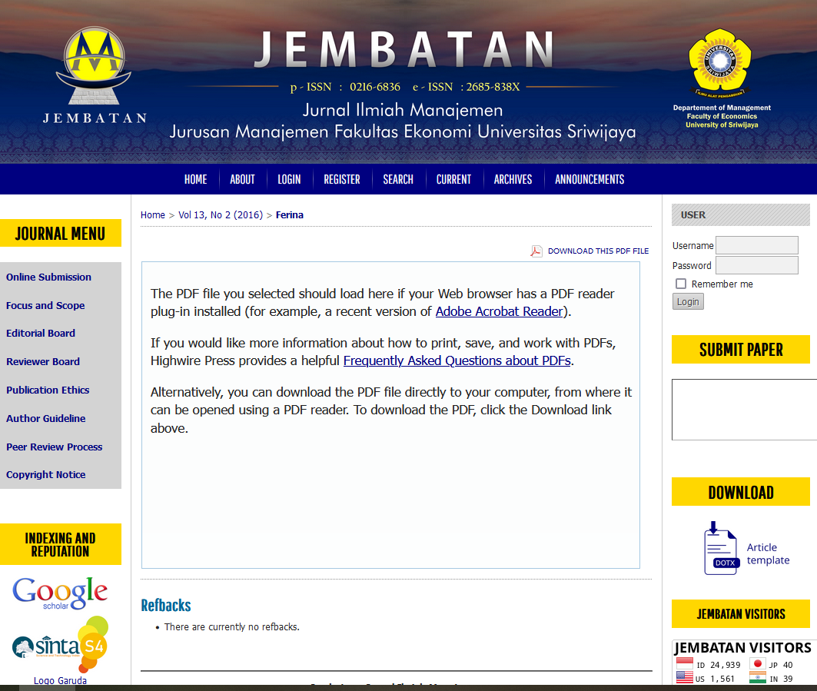
https://ejournal.unsri.ac.id/index.php/jembatan/article/view/4022/pd

